* Cai dat python 2.7 or later : <https://www.python.org/downloads/release/python-2715/>
* Cai dat pip cho python
* To install pip, securely download [get-pip.py](https://bootstrap.pypa.io/get-pip.py). [[1]](https://pip.pypa.io/en/latest/installing/#id7):
* curl https://bootstrap.pypa.io/get-pip.py -o get-pip.py
* As when running any script downloaded from the web, ensure that you have reviewed the code and are happy that it works as you expect. Then run the following:
* python get-pip.py
* Kiem tra version pip : pip –V

Cai dat nrfutil : pip install nrfutil

* To check for update, call pip install nrfutil –upgrade
* Tao ra private.key va public.key
* Private.key de tao ra file firmware.zip
* Public.key de add vao project, remove dfu_public_key.c tu project
* Build the bootloader
* Download thu vien mo rong : <https://github.com/kmackay/micro-ecc>
* Tao 1 folder micro-ecc de chua : D:\BLE\Lesson\nRF5_SDK_15.1.0_a8c0c4d\external\micro-ecc\micro-ecc.
* Tai <https://osdn.net/projects/mingw/downloads/68260/mingw-get-setup.exe/>
* Cai cac goi nhu sau

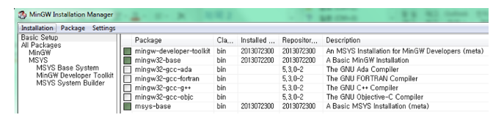

* Vao duong dan C:\MinGW\msys\1.0 chay file msys.bat
* Dan vao thu muc

+ D:\BLE\Lesson\nRF5_SDK_15.1.0_a8c0c4d\external\micro-ecc\nrf52hf_armgcc\armgcc -> make neu dung ses

+ D:\BLE\Lesson\nRF5_SDK_15.1.0_a8c0c4d\external\micro-ecc\nrf52hf_keil\armgcc -> make neu dung keilC

* D:\BLE\Lesson\nRF5_SDK_15.1.0_a8c0c4d\components\toolchain\gcc\Makefile.windows sua lai nhu sau

GNU_INSTALL_ROOT := C:/Program Files (x86)/GNU Tools ARM Embedded/4.9 2015q3/bin/

GNU_VERSION := 6.3.1

GNU_PREFIX := arm-none-eabi

* Tao chuong trình de update
* mergehex --merge hexfile1.hex hexfile2.hex --output output.hex
* nrfjprog.exe --family NRF52 -e // xoa het
* nrfjprog.exe --family NRF52 --program s132_nrf52_5.0.0_softdevice.hex --chiperase –verify // nap chuong trình co SD  
  nrfjprog.exe --family NRF52 --program nrf52832_xxaa.hex –verify // nap nguyen chuong trình không co SD  
  nrfjprog.exe --family NRF52 --reset
* Tao file firmware.zip
* Chuan bi 1 file blinky.hex (S132) va file private.key
* nrfutil pkg generate --hw-version 52 --application-version 1 --application nrf52832_xxaa.hex --sd-req 0x98 --key-file private.key app_dfu_package.zip
* Dung nrfGo Studio de biet ma –sd-reg cua SD
* Hoac go nrfutil pkg generate –help

|s112_nrf51_6.0.0|0xA7|

|s130_nrf51_1.0.0|0x67|

|s130_nrf51_2.0.0|0x80|

|s132_nrf52_2.0.0|0x81|

|s130_nrf51_2.0.1|0x87|

|s132_nrf52_2.0.1|0x88|

|s132_nrf52_3.0.0|0x8C|

|s132_nrf52_3.1.0|0x91|

|s132_nrf52_4.0.0|0x95|

|s132_nrf52_4.0.2|0x98|

|s132_nrf52_4.0.3|0x99|

|s132_nrf52_4.0.4|0x9E|

|s132_nrf52_4.0.5|0x9F|

|s132_nrf52_5.0.0|0x9D|

|s132_nrf52_5.1.0|0xA5|

|s132_nrf52_6.0.0|0xA8|

|s132_nrf52_6.0.1|0xAf|

* Dung segger nap chuong trình bootloader . Nho remove file dfu_public_key.c va add file public.key
* Tao file hex de update
* Chuan bi cac file sau :

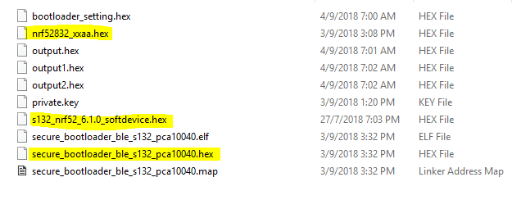

* Tao bootloader_setting.hex

nrfutil settings generate --family NRF52 --application nrf52832_xxaa.hex --application-version 0 --bootloader-version 0 --bl-settings-version 1 bootloader_setting.hex

Trong do nrf52832_xxaa.hex la file application firmware minh muon chay cung voi chuong trình bootloader (o day la project blinky).

Merger bootloader_setting.hex va application firmware va SD ->> nap

mergehex --merge bootloader_setting.hex secure_bootloader_ble_s132_pca10040.hex --output output.hex

mergehex --merge output.hex s132_nrf52_6.1.0_softdevice.hex --output output1.hex

mergehex --merge output1.hex nrf52832_xxaa.hex --output output2.hex

nrfjprog.exe --family NRF52 --program output2.hex –verify

nrfjprog.exe --family NRF52 --reset